Home Work Data Viz Live 01

tamakuku

2024-01-09

# **install packages and call library must using**

install.packages("ggplot2")  
install.packages("tidyverse")  
  
library(ggplot2)  
library(tidyverse)

# **Chart 1**. Bar plot >>> to find the popular model produced by Ford’s cars.

ggplot( mpg %>%  
 filter( manufacturer  
 == "ford" ), aes( x = model, fill = model ) ) +  
 geom_bar() +  
 theme_minimal() +  
 labs( title = "Bar chart: Ford's model cars produced",  
 x = "Model's Cars",  
 y = "Count of cars",  
 caption = "Source from mpg dataframe based on R")

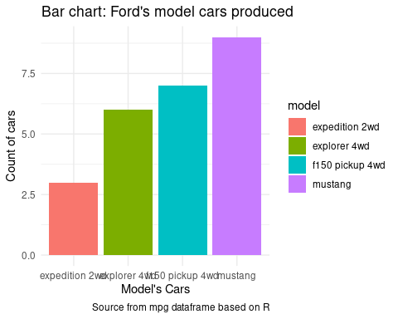

## *insight Chart 1. : The Mustang is the most popular model car produced by Ford’s manufacturer.*

## **Chart 2.** Histogram plot >>> to Segment ‘displ’ (or engine displacement, in liters) of cars was produced.

ggplot( mpg, aes( x = displ ) ) +  
 geom_histogram( bins = 10, fill = "red", col = "grey") +  
 theme_minimal() +  
 labs( title = "Histogram chart: Segment displ of cars produced",  
 x = "Engine displacement, in liters",  
 y = "Count of cars",  
 caption = "Source from mpg dataframe based on R" )

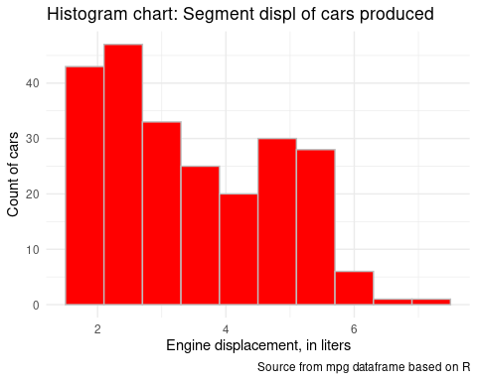

## *insight: If a car’s have ‘displ’(or engine displacement) more than 6 liters, it is less was produced.*

# **Chart 3.** Scatter plot >>> to find a relationship between ‘displ’(or engine displacement, in liters) and ‘cty’(or city distance, in miles per gallon).

ggplot( mpg, aes( x = displ, y = cty, color = displ) ) +  
 geom_point() +  
 geom_smooth( method = "lm", alpha = 0.2 ) +  
 scale_color_gradient( low = "purple", high = "gold") +  
 theme_minimal() +  
 labs( title = "Scatter chart: Relationship displ & cty",  
 x = "engine of cars, in liters",  
 y = "miles per gallon, city driving",  
 caption = "Source from mpg dataframe based in R" )

## Warning: The following aesthetics were dropped during statistical transformation: colour  
## ℹ This can happen when ggplot fails to infer the correct grouping structure in  
## the data.  
## ℹ Did you forget to specify a `group` aesthetic or to convert a numerical  
## variable into a factor?

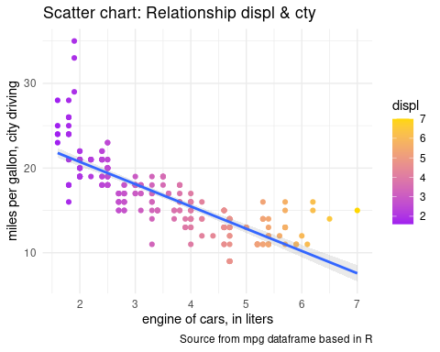

## *insight: If a car’s ‘displ’(or engine displacement) has more liters, it can drive less distance in the city.*

# **Chart 4.** Scatter plot by 2 data.frame >>> to compare Ford and Audi by auto gear, which one can drive long distances on highways?

ford_auto <- mpg %>%  
 select( manufacturer, trans, hwy ) %>%  
 filter( manufacturer == "ford" & grepl( "auto", mpg$trans ) )  
audi_auto <- mpg %>%   
 select( manufacturer, trans, hwy ) %>%  
 filter( manufacturer == "audi" & grepl( "auto", mpg$trans ) )  
  
ggplot() +  
 geom_point( data = ford_auto, aes( x = hwy , y = manufacturer ), color = "blue" ) +  
 geom_point( data = audi_auto, aes( x = hwy , y = manufacturer ), color = "red" ) +  
 theme_minimal() +  
 labs( title = "Scatter chart Auto Gear's cars Ford vs Audi",  
 x = "Highway distance, miles per gallon",  
 y = "Count of auto gear's cars",  
 caption = "Source from mpg dataframe based in R")

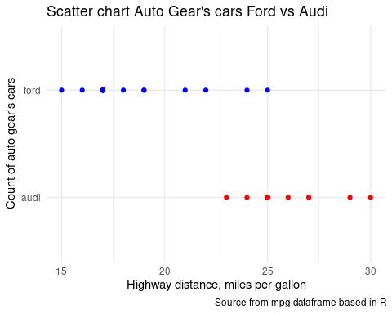

## *insight: When comparing two manufacturer’s cars with auto gear, Audi can drive on the highway for more distance than Ford.*

# **Chart 5.** Scatter plot with Mapping + Facet >>> to find the relationship between ‘cyl’ (or number of cylinders) and ‘cty’ (or city distance, in miles per gallon), in each class of cars.

ggplot( mpg %>%  
 filter( manufacturer == "ford"),  
 aes( x = cty, y = cyl, color = class) ) +  
 geom_point() +  
 geom_smooth( method = "lm") +  
 geom_rug() +  
 facet_grid( ~class ) +  
 theme_minimal() +  
 labs( title = "Multi Scatter chart: Relationship cyl & cty in each class",  
 x = "City distance, miles per gallon",  
 y = "Number of cylinders",  
 caption = "Source from mpg dataframe based in R")

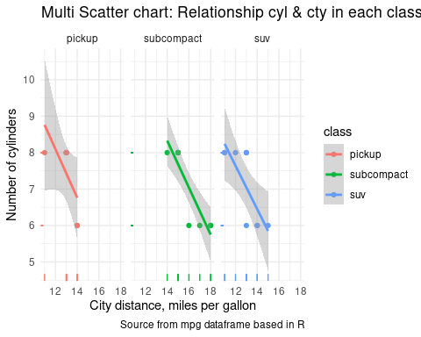

## *insight: The subcompact class of Ford has six cylinders; it’s the best Eco’s car.*